**Admin panel (Roll based) for Salesbuddy**

This SOP outlines the procedures for the Master Admin to manage the admin panel, which includes adding users as admin, assign necessary roles and remove admin as needed.

**Process Overview:**

The Master Admin has the authority to add users as admin, assign necessary roles and remove admin as needed from the admin panel. Here are the step-by-step instructions for these actions:

* **To Add a User as Admin:**

**Step1: Access the Admin Panel:**

- Log in to the system as a Master Admin and access the Admin Panel.

**Step2: Add New User:**

- In the Admin Panel, locate the "Add New User" form.

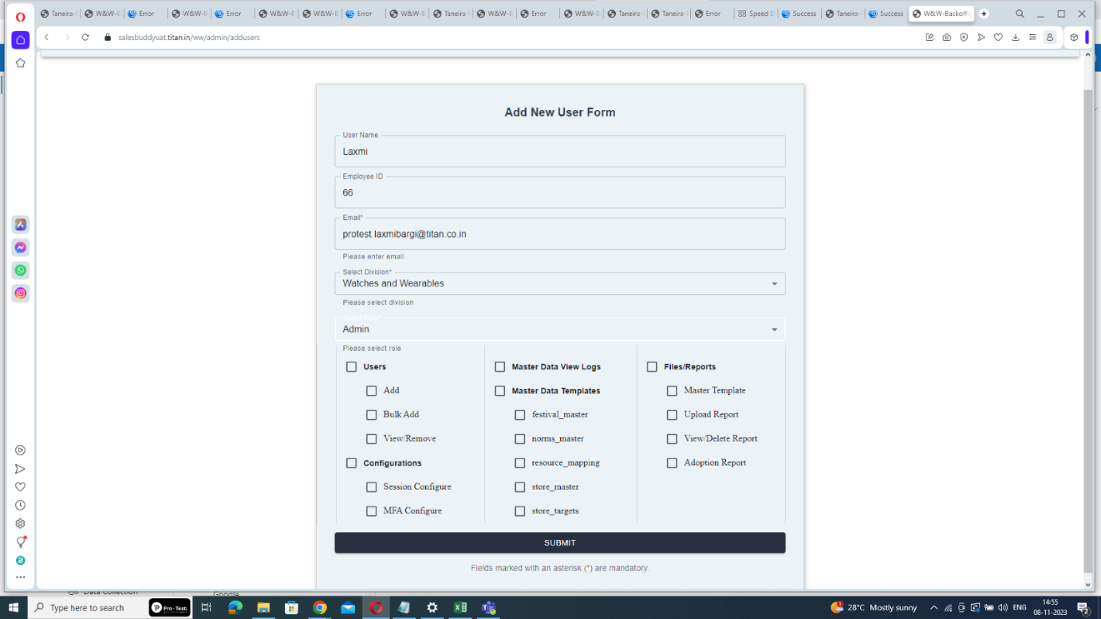

**Step3: Enter User Details:**

- Fill in the new user's details, including their Username, Employee ID, Email, division, and select the role as "Admin".

**Step4: Grant Access to Necessary Roles:**

**-** Assign access to necessary roles by clicking on the corresponding column and click "Submit" to save the user details.



Click here to select only necessary roles

Click here to select all the roles comes under particular section

**Step5: Email notification:  
 -** The user will receive an email with their username and password for login.

**Step6: User Login:**

- The newly added admin can log in using the provided username and password by clicking to the link.

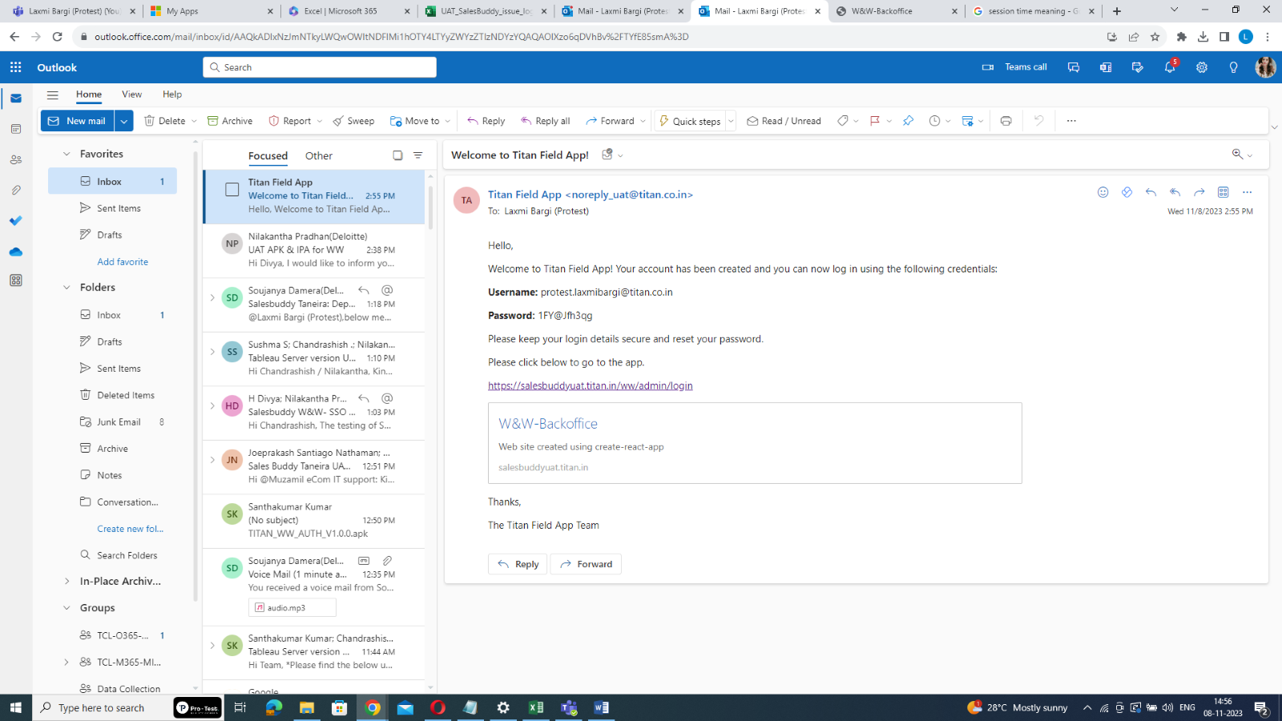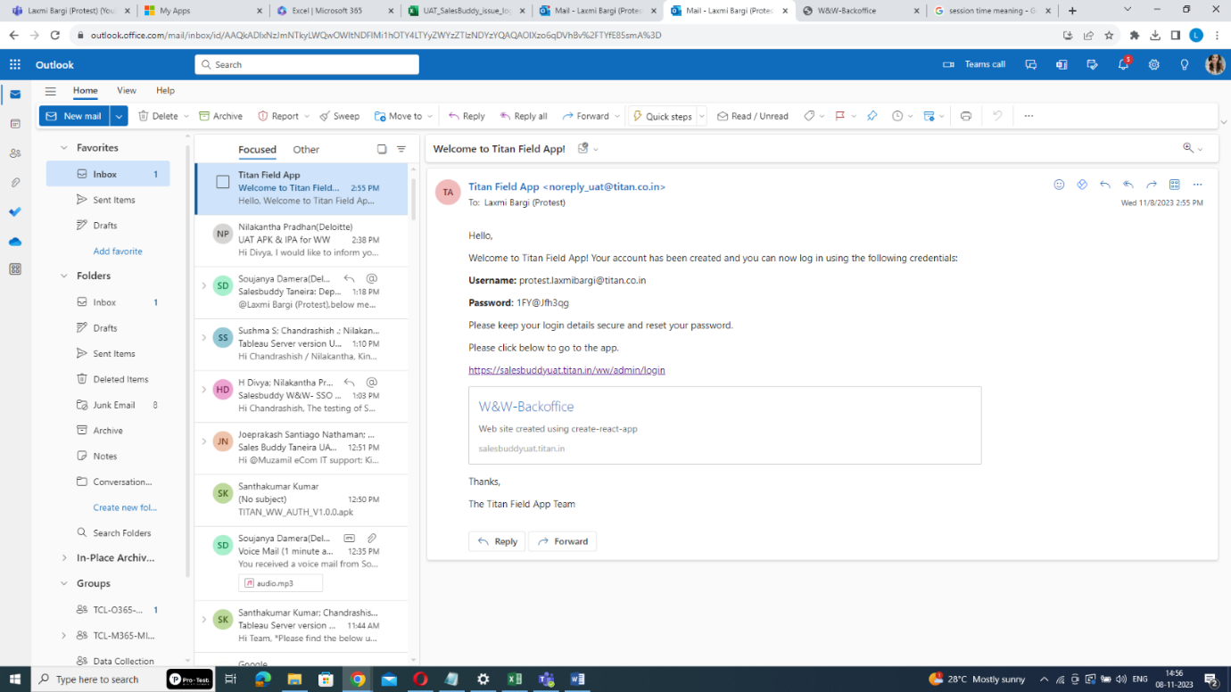

Username and initial password

Link to login

**Step7: Reset the Password:**

- After entering the Username & initial password, click "LOG IN". The system will redirect you to the password reset page. In reset password page, create a new password. Ensure that it meets the following criteria

* 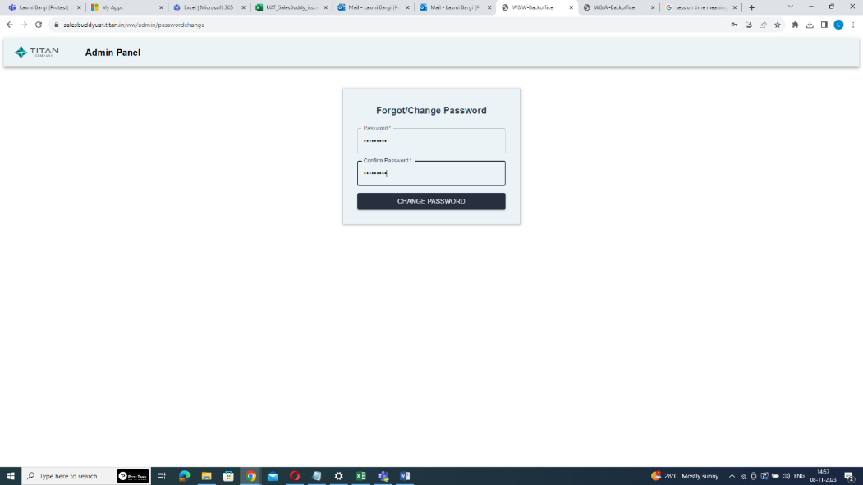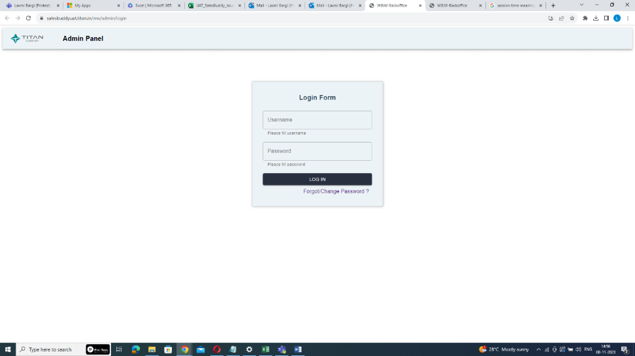Password length must be at least 10 characters.

Create a new password

* At least 1 digit.

Enter username and initial password sent through email

* At least 1 lowercase letter.
* At least 1 uppercase letter.
* At least 1 non-alphanumeric special character.

**Step8: Confirm the Password:**

- Re-enter the newly created password for confirmation & click on “change password” button.

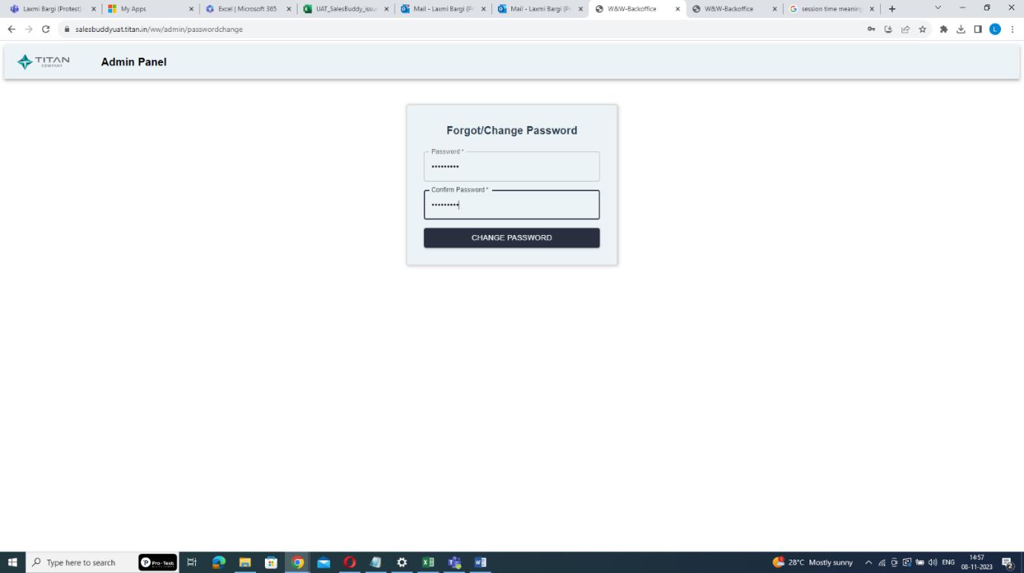

Confirm your password

**Step9: Click on re-login:**

**-** To go back to the login page click “re-login” & Re-login using your email ID and the newly created password.

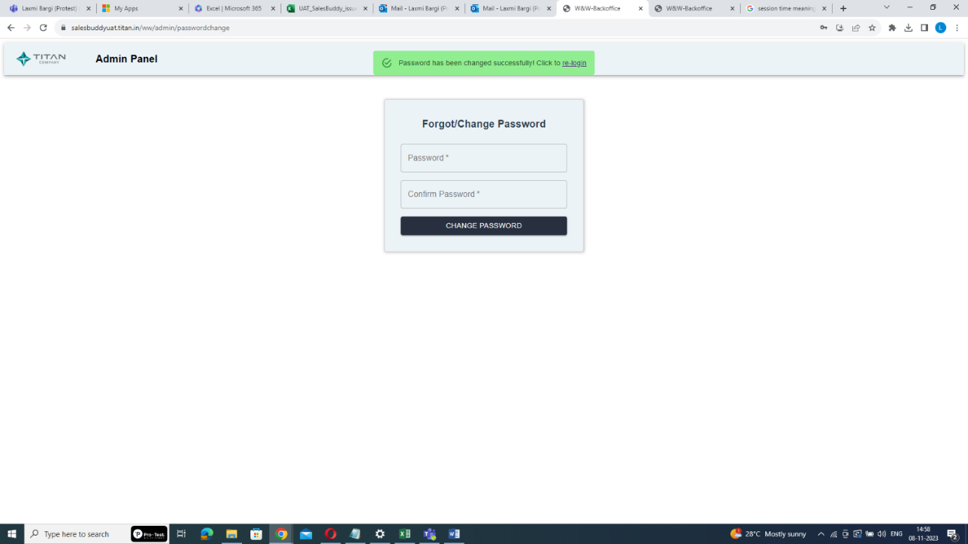

Click here

* **To Update User Roles:**

**Step1: Access the Admin Panel:**

**-** Log in to the system as a Master Admin and access the Admin Panel.

**Step2: Search for the User:**

- Enter the user's email and click "Search".

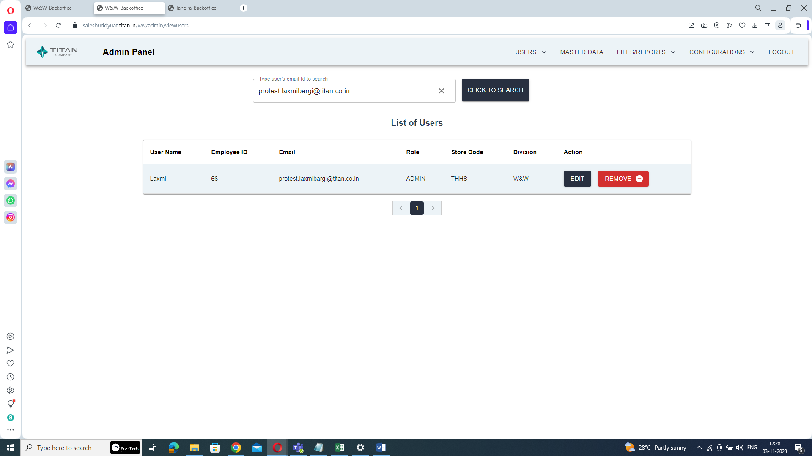

Enter user’s email-id

**Step3: Edit User Roles:**

- Click on the "Edit" button to update the user's roles.



Click on EDIT

**Step4: Add or Remove Access:**

- Modify the user's access by adding or removing necessary roles.

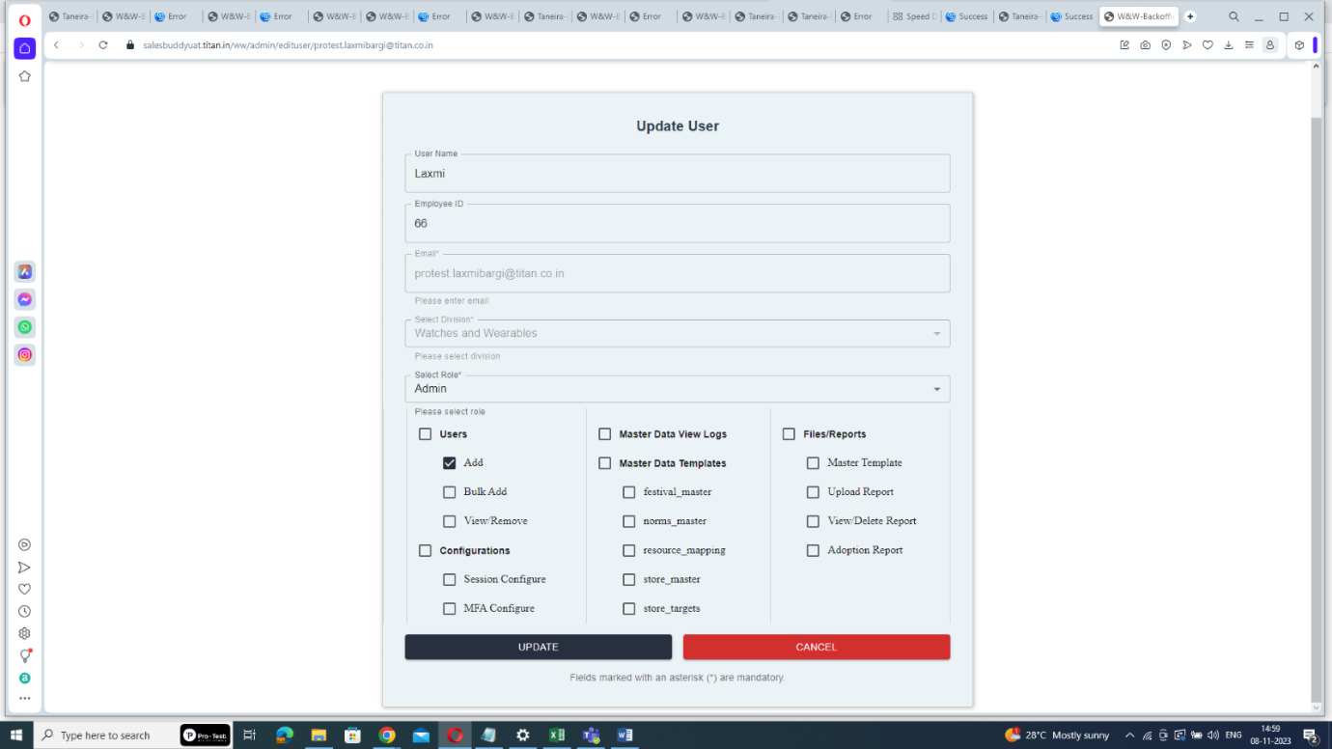

add or remove roles here

**Step5: Submit the Changes:**

- Click "Submit" to save the updated roles,

* **To remove a user:**

**Step1: Access the Admin Panel:**

**-** Log in to the system as a Master Admin and access the Admin Panel.

**Step2: Search for the User:**

- Enter the user's email and click "Search".



Enter user’s email-id

**Step3: Remove the User:**

- Click on the "Remove" button to delete the user as admin.



Click on Remove

By following these steps, the Master Admin can efficiently manage users’s roles within the admin panel, ensuring that users have the appropriate access and responsibilities as required.